Question Bank-Unit 1
Numerical Methods: MATH 2300
B.Tech , III Sem
(Non-linear equations and system of linear equations)

S. No. | Questions | CO | Bloom’s Taxonomy Level | Difficulty Level | Competitive Exam Question Y/N | Area | Topic
1 | Define Inherent error with example | CO1 | K1 | L | N | Errors | Types of error
2 | Define round off error with example | CO1 | K1 | M | N | Errors | Types of error
3 | Define truncation error with example | CO1 | K1 | M | N | Errors | Types of error
4 | Define absolute error | CO1 | K1 | M | N | Errors | Types of error
5 | Define relative error | CO1 | K1 | M | N | Errors | Types of error
6 | Define percentage error | CO1 | K1 | L | N | Errors | Types of error
.7 | Round off the number 3.6252782 up to 3 decimal places | CO1 | K2 | M | N | Errors | Accuracy of numbers
8 | How many significant digits in the number 35.00537 | CO1 | K1 | M | N | Errors | Accuracy of numbers
9 | The number 56.487262is correct up to three decimal places then maximum absolute error is……………. | CO1 | K2 | L | N | Errors | Accuracy of numbers
10 | Let  be a function of and , write the formula for maximum absolute error in the function | CO1 | K1 | L | N | Errors | Error in the approximation of a function
.11 | Distinguish between round off errors and truncation errors. | CO1 | K2 | M | N | Errors | Types of error
12 | A root of the equation 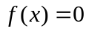 is that value of x where the graph of the function …… ………………. the x-axis. | CO1 | K2 | M | N | Non-linear equations | Basic properties of equation
13 | What is a transcendental equation? Elaborate with suitable examples. | CO1 | K1 | L | N | Non-linear equations | Basic properties of equation
14 | Differentiate between polynomial and transcendental equations by giving two examples of each. | CO1 | K2 | M | N | Non-linear equations | Basic properties of equation
15 | State the Intermediate Value Theorem. Where do we apply the theorem in our course? | CO1 | K1 | L | N | Non-linear equations | Basic properties of equation
16 | Explain the basic principle of root finding by Bisection method. | CO1 | K2 | M | N | Non-linear equations | Bisection method
17 | Find the number of iterations required in finding the root of a equation by Bisection method for achieving an accuracy . | CO1 | K1 | M | N | Non-linear equations | Bisection method
18 | Find the interval in which a real root of 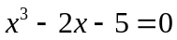 lies. | CO1 | K3 | L | N | Non-linear equations | Basic properties of equation
19 | Write the iteration methods in the descending order of their order of convergence: Newton- Raphson method, Regula- Falsi method, Secant method. | CO1 | K2 | L | N | Non-linear equations | Convergence of iterative methods
20 | Write condition of convergence of Newton-Raphson method. | CO1 | K2 | M | N | Non-linear equations | Convergence of iterative methods
21 | Under what condition secant method fails to converge to a solution. | CO1 | K2 | M | N | Non-linear equations | Secant method
22 | Give the geometrical interpretation of fixed-point iteration method. | CO1 | K2 | M | N | Non-linear equations | Fixed point method
23 | Discuss the situations where the fixed-point iteration process may not converge to a solution. | CO1 | K2 | M | N | Non-linear equations | Fixed point method
24 | What is difference between direct methods and iterative methods. Give some examples | CO1 | K2 | M | N | System of linear equations | System of linear equations
25 | Write sufficient condition for the convergence of Gauss Seidel method. | CO1 | K1 | L | N | System of linear equations | Gauss Seidel method.
26 | Round off the 0.77729, 0.0022218 numbers to four significant digits. | CO1 | K3 | L | N | Errors | Accuracy of numbers
27 | Find the absolute and relative error in 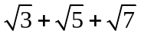correct to 4 significant digits. | CO1 | K3 | H | N | Errors | Accuracy of numbers
28 | Round off the numbers 865250 and 37.46235 to four significant figures and compute absolute, relative and percentage error in each case | CO1 | K3 | M | N | Errors | Accuracy of numbers
29 | Find the absolute error if the number 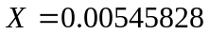is  - Truncated to three decimal places  - Rounded off to three decimal places. | CO1 | K3 | M | N | Errors | Accuracy of numbers
30 | If 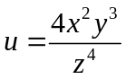and errors in x, y, z be 0.001, compute the maximum absolute, relative, percentage error in , when 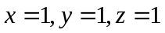 | CO1 | K3 | M | N | Errors | Error in the approximation of a function
31 | The error in the measurement of the area of circle is not allowed to exceed 0.1%. How accurately should the diameter be measured? | CO1 | K3 | H | N | Errors | Error in the approximation of a function
32 | Compute the percentage error in the time period 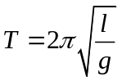for 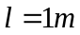, if the error in the measurement of is 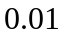 | CO1 | K3 | M | N | Errors | Error in the approximation of a function
33 | Using Regula-Falsi method, compute the real root of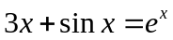. Perform three iterations. | CO1 | K3 | M | N | Non linear equations | Regula- Falsi method
34 | Find a root of the equation 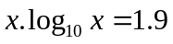 by secant method. Perform four iterations. | CO1 | K3 | M | N | Non linear equations | Secant method
35 | Find a root of 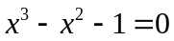 using the Newton-Raphson method correct to three decimal places. | CO1 | K3 | M | N | Non linear equations | Newton- Raphson method
36 | The bacteria concentration in a reservoir varies as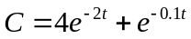. Using Newton-Raphson method calculate the time required for the bacteria concentration to be 0.5. | CO1 | K4 | H | N | Non linear equations | Newton- Raphson method
37 | Use the fixed-point iteration method to find a root of the equations: 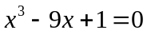 | CO1 | K3 | H | N | Non linear equations | Fixed point method
38 | What is the convergence criteria for the Fixed Point method? Can the method be applied to find a real root of the equation: 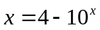? | CO1 | K4 | H | N | Non linear equations | Fixed point method
39 | Solve the following equations by using Gauss elimination method:  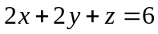, 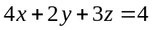, 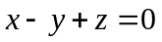. | CO1 | K4 | M | N | System of linear equations | Gauss Elimination method
40 | Find a root of the equation 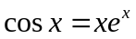 by Bisection method. Perform six iterations. | CO1 | K3 | M | N | Non linear equations | Bisection method
41 | Using Bisection method, find a negative root of the equation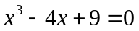. Perform six iterations. | CO1 | K3 | M | N | Non linear equations | Bisection method
42 | Show that rate of convergence of Newton-Raphson method is quadratic | CO1 | K4 | H | N | Non linear equations | Newton- Raphson method
43 | Find a positive root of 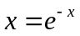by using fixed-point iteration process with the initial guess as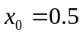, correct up-to four places of decimal. | CO1 | K4 | H | N | Non linear equations | Fixed point method
44 | Define the rate of convergence. Show that the rate of convergence fixed point method is linear. | CO1 | K4 | H | N | Non linear equations | Convergence of iterative methods
45 | Find the positive root of the equation 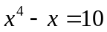correct to three decimal places, using Newton- Raphson’s method. | CO1 | K3 | H | N | Non linear equations | Newton- Raphson method
46 | Find by Newton- Raphson’s method, the real root of the equation 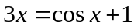, correct to four decimal places. | CO1 | K3 | M | N | Non linear equations | Newton- Raphson method
47 | Find the root of the equation using secant method correct to three decimal places. | CO1 | K3 | L | N | Non linear equations | Secant method
48 | Use the method of False-position, to find the fourth root of 32 correct to three decimal places. | CO1 | K3 | H | N | Non linear equations | Regula- Falsi method
49 | Solve the following system of linear equations by Gauss Jordan method:  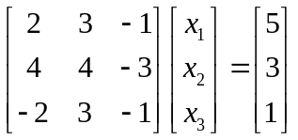 | CO1 | K3 | M | N | System of linear equations | Gauss Jordan method
50 | Solve the following system of linear equations by Gauss Jordan method:  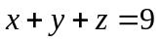, 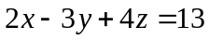, 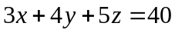 | CO1 | K4 | M | N | System of linear equations | Gauss Jordan method
51 | Find the solution of the system of equations:  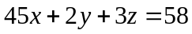, 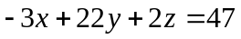, 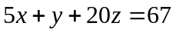  Perform 3 iterations, using the Gauss-Seidel iteration method. | CO1 | K4 | H | N | System of linear equations | Gauss Seidel method
52 | Test if the following system of equations is diagonally dominant and hence solve this system of equations by using Gauss Seidel method. Perform four iterations:  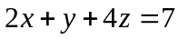, 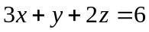, 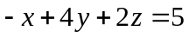. | CO1 | K3 | H | N | System of linear equations | Gauss Seidel method
53 | Find the fourth root of 32 by Newton- Raphson’s method, correct to four decimal places. | CO1 | K3 | H | N | Non linear equations | Newton- Raphson method
54 | Find the interval in which a real root of equation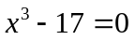 lies. | CO1 | K3 | L | N | Non-linear equations | Basic properties of equation
55 | Round off the numbers 32.265 and 0.002358 correct to 2 decimal places. | CO1 | K3 | L | N | Errors | Accuracy of numbers

